Adverbs of Time

🔹 What Are Adverbs of Time?
# Source: AI Source: Provided by: [Data Path: Persons Table -> ID Column: 1, Name_En Column: Motasem Essam] -> From: [Chatgpt (GPT-4-turbo)] on [7/27/2025]
Adverbs of time tell us when, how long, or how often something happens.
They describe the time of an action or event and usually answer the question: 👉 "When?"

✅ Common Adverbs of Time
# Source: AI Source: Provided by: [Data Path: Persons Table -> ID Column: 1, Name_En Column: Motasem Essam] -> From: [Chatgpt (GPT-4-turbo)] on [7/27/2025]
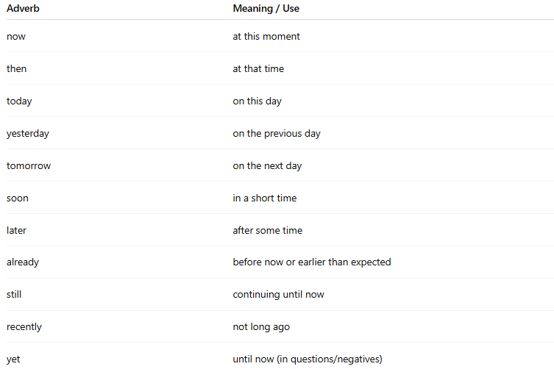
Adverb | Meaning / Use
now | at this moment
then | at that time
today | on this day
yesterday | on the previous day
tomorrow | on the next day
soon | in a short time
later | after some time
already | before now or earlier than expected
still | continuing until now
recently | not long ago
yet | until now (in questions/negatives)

📚 Examples in Sentences
# Source: AI Source: Provided by: [Data Path: Persons Table -> ID Column: 1, Name_En Column: Motasem Essam] -> From: [Chatgpt (GPT-4-turbo)] on [7/27/2025]
- I will call you later.
- She arrived yesterday.
- We’re leaving now.
- He hasn’t finished his work yet.
- They already left the house.

🧠 Key Points
# Source: AI Source: Provided by: [Data Path: Persons Table -> ID Column: 1, Name_En Column: Motasem Essam] -> From: [Chatgpt (GPT-4-turbo)] on [7/27/2025]
- Can go at the beginning or end of a sentence:
✅ Today, we have a test.
✅ We have a test today.
- Some can go in the middle of a sentence:
✅ She has already eaten.
- Often used in tenses like present perfect, past simple, future, etc.

